Some Hints on Using Azure Lab VMs Outside of the Classroom

You will use the same VM (Virtual Machine) for your lab that you were assigned in your first class.

For any of this to work you must be on the physical Progressive network, on premises*[1].

To access the lab VM, you **must** have the Open Text Socks Client installed *and* enabled.

Access the app from the task tray in Windows (bottom right corner, the up-arrow carrot).

It is the icon with the circle with an arrow emerging. Right click on the icon, and make sure the “Enable Open Text SOCKS Client” is checked. If it is not, click it to enable it (you will probably have to allow it to make changes through User Access Control).

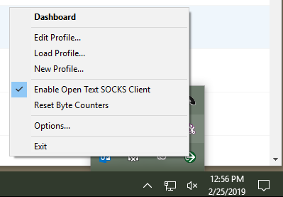

**When you are done using the lab VM, DISABLE the Open Text Socks Client by clicking the “Enable Open Text SOCKS Client” option again. Failure to do so will stop you from accessing internal Progressive Virtual Machines. YOU DO NOT NEED TO UNINSTALL THE CLIENT.**

You access your lab VM by going to <https://labs.azure.com/> with either Google Chrome of Microsoft Edge (**not** Internet Explorer).

Click the “sign in” button in the upper right-hand corner. It should automatically sign you in using your Progressive credentials, and show your Virtual Machine.

You should see your VM listed. Click the “start” icon, wait a few moments for your VM to boot, and then click the “connect” icon. An “rdp” file will be downloaded to your downloads folder. Open that file and log in as instructed in the classroom.

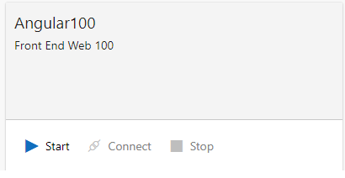

Occasionally you may have a problem connecting. This is often solved by just stopping then restarting the VM.

Please remember to shut down your VM when you aren’t using it (from the labs.azure.com page, click the “stop” icon next to your VM). Progressive is charged for the use of these virtual machines.

You must also belong to the two security groups you requested access to before training. To verify that you have access to those groups, you can open Powershell on your PC and paste in the following command and execute it:

(New-Object System.DirectoryServices.DirectorySearcher("(&(objectCategory=User)(samAccountName=$($env:username)))")).FindOne().GetDirectoryEntry().memberOf | Where-Object { $_ -eq "CN=P-U-WEB0022,CN=Users,DC=prog1,DC=com" -or $_ -eq "CN=P-U-WEB3389,CN=Users,DC=prog1,DC=com" }

After you run the command, the two group names (P-U-WEB002, P-U-WEB3389 ) should be listed. If both or either are missing, your access to the group has been revoked and you will have to request it again.

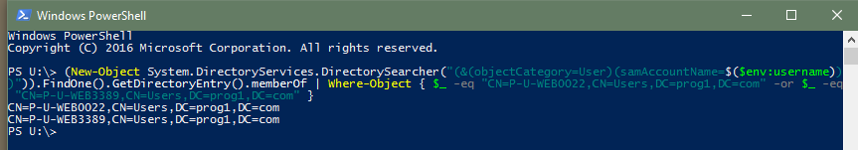

1. You can remote desktop into a machine on the Progressive network that you have access to, and has the Open Text SOCKS Client installed and use that.